STUDENT DATABASE MANAGEMENT SYSTEM
21CSC205P Database Management Systems
A MINI PROJECT REPORT
Submitted by
SHARVESWAR.M – RA2411003011058
MAGI SHARMA J – RA2411003011058
Under the Guidance of
Mr Karthikeyan
(DBMS STAFF, B.Tech)
in partial fulfilment of the requirements for the degree of
BACHELOR OF TECHNOLOGY
in
COMPUTER SCIENCE ENGINEERING

DEPARTMENT OF NETWORKING AND COMMUNICATIONS
SCHOOL OF COMPUTING
COLLEGE OF ENGINEERING AND TECHNOLOGY
SRM INSTITUTE OF SCIENCE AND TECHNOLOGY
KATTANKULATHUR- 603 203
MAY 2026
SRM INSTITUTE OF SCIENCE AND TECHNOLOGY KATTANKULATHUR – 603 203

BONAFIDE CERTIFICATE
Certified that Project report titled “STUDENT DATABASE MANAGEMENT SYSTEM” is the bonafide work of “SHARVESWAR.M-RA2411003011058, MAGI SHARMA J – RA2411003011045” who carried out the 21CSC205P Database Management Systems mini project work under my supervision.

SIGNATURE

COURSE FACULTY | HEAD OF THE DEPARMENT
DESIGNATION  Department | PROFESSOR AND HEAD  Department
ABSTRACT
The Student Database Management System is a web-based application developed to streamline and automate the management of student records in educational institutions. The system uses a normalized 6-table relational database to store student data across separate entities: Students, Guardians, Academic Records, Attendance, Assessments, and Fee Records. Built using Next.js for the frontend and PostgreSQL for the backend, the application ensures data integrity through foreign key constraints with cascading deletes and transactional writes across all tables. Key features include a comprehensive student dashboard, multi-table data entry, and a searchable view with expandable student details. The implementation of normalization techniques (up to 3NF) ensures an optimized database design, while transaction management guarantees data consistency during concurrent operations.

TABLE OF CONTENTS
Chapter No. | Title | Page no.
 | ABSTRACT
1 | Problem understanding, Identification of Entity and Relationships, Construction of DB using ER Model | 7
 | 1.1 Introduction
 | 1.2 Motivation
 | 1.6 Identification of Entity and Relationships
 | 1.7 Construction of DB Using ER Model
2 | Design of Relational Schemas, Creation of Database and Tables | 11
 | 2.1 Relational Schema
 | 2.3 Creation of Database and Tables - DDL Commands
3 | Writing Complex Queries | 20
 | 3.1 Adding Constraints
 | 3.2 Aggregate Functions
 | 3.3 Sets, Subqueries, Joins, Views, Triggers, Cursors
4 | Normalization Analysis (1NF to 5NF) | 25
5 | Implementation of Concurrency Control and Recovery Mechanisms | 30
6 | Front-end And Back-End Implementation Code | 34
7 | Results and Discussions | 41

LIST OF FIGURES
Figure No. | Name | Page no.
1.1 | ER Diagram of Student Database Management System | 10
2.1 | Schema for Student Database Management System | 12
7.1 | Home Page of Student Database Management System | 41
7.2 | Student List View with Search Logic | 41
7.3 | Detailed View of a Student Record | 42
7.4 | Data Entry Form for New Students | 42
7.5 | Database Connection Verification | 43

LIST OF TABLES
Table No. | Name | Page no.
2.2 | Description of All 6 Tables | 13
2.4 | Department-wise Statistics | 19
3.2 | Students with Above Average GPA | 21
3.3 | Students Meeting Criteria (Sets) | 21
3.5 | Sibling Pairs (Self-Join) | 22
3.6 | High Achievers View | 23

CHAPTER 1
PROBLEM UNDERSTANDING, IDENTIFICATION OF ENTITY AND RELATIONSHIPS, CONSTRUCTION OF DB USING ER MODEL FOR THE STUDENT DATABASE MANAGEMENT SYSTEM
1.1 Introduction
The Student Database Management System (SDMS) is a comprehensive software solution designed to streamline the management of student information within an educational institution. In the traditional manual system, maintaining student records, including personal details, academic performance, attendance, and fee payments, is a tedious and error-prone process. This project aims to digitize these operations, providing a centralized platform for administrators, faculty, and students to access and manage data efficiently.
The system is built using modern web technologies, ensuring accessibility, scalability, and security. It facilitates real-time data updates, generates insightful reports, and simplifies administrative tasks such as admission processing and result analysis. By automating routine operations, the SDMS enhances the overall productivity of the institution and ensures data integrity.
1.2 Motivation
The primary motivation behind developing this system is to address the inefficiencies of paper-based record-keeping. Educational institutions handle vast amounts of data, and manual processing often leads to:
- Data Redundancy: Multiple copies of the same data across different departments.
- Inconsistency: Discrepancies in student records due to manual entry errors.
- Time Consumption: Retrieving specific student information takes significant time.
- Security Risks: Physical records are susceptible to damage or unauthorized access.
By transitioning to a digital database management system, we aim to eliminate these challenges, ensuring that student data is accurate, secure, and easily retrievable. The motivation is to create a robust system that supports the academic and administrative needs of the college.
1.3 Scope
The scope of the Student Database Management System includes:
- Student Information Management: Storing personal, academic, and contact details.
- Academic Records: Managing semester-wise marks, GPA, CGPA, and credit hours.
- Attendance Tracking: Recording daily attendance and calculating percentages.
- Fee Management: Tracking fee payments, dues, and scholarship details.
- Search and Filter: enabling quick search of students by ID, name, or department.
- Data Export: Facilitating the export of student data for reporting purposes.
The system is designed for use by the college administration and faculty, with potential for future expansion to include a student portal.
1.4 Problem Statement
The current manual system for managing student data is inefficient and prone to errors. Administrators struggle to maintain up-to-date records of hundreds or thousands of students. Tracking fee payments, calculating attendance percentages, and generating academic reports manually is labour-intensive. There is a need for an automated, centralized system that can handle student data securely and provide quick access to information for decision-making.
1.5 Project Requirements
Functional Requirements:
- The system must allow the addition, update, deletion, and viewing of student records.
- It should calculate GPA and CGPA automatically based on marks.
- It must track fee status and highlight students with pending dues.
- It should support data validation to prevent invalid entries (e.g., negative marks).
Non-Functional Requirements:
- Performance: The system should respond to queries within 2 seconds.
- Scalability: It must handle a growing number of student records without performance degradation.
- Security: Access to the database should be restricted to authorized personnel.
- Usability: The user interface should be intuitive and easy to navigate.
1.6 Identification of Entity and Relationships
Based on the problem statement, the key entity identified for this phase is the student. In a more complex scenario, this would be broken down into multiple entities, but for the initial scope, we are utilizing a comprehensive schema.
Entities:
- Student — Core identity and contact information.
  - Attributes: Student ID (PK), Full Name, DOB, Gender, Address, Phone, Email, Admission Date.
- Guardian — Parent/guardian details.
  - Attributes: Guardian ID (PK), Student ID (FK), Name, Phone, Email, Relationship.
- Academic Record — Enrollment and academic performance.
  - Attributes: Record ID (PK), Student ID (FK), Enrollment Status, Program, Department, Semester, Credit Hours, GPA, CGPA.
- Attendance — Class attendance tracking.
  - Attributes: Attendance ID (PK), Student ID (FK), Semester, Classes Attended, Total Classes, Percentage.
- Assessment — Examination marks and grades.
  - Attributes: Assessment ID (PK), Student ID (FK), Semester, Internal Marks, Quiz Marks, Semester Marks, Total Marks, Grade.
- Fee Record — Financial tracking.
  - Attributes: Fee ID (PK), Student ID (FK), Total Fees, Fees Paid, Pending Dues, Payment Status, Scholarship Amount, Scholarship Type.
Relationships:
- A Student has one Guardian (1:1 or 1:N).
- A Student has one Academic Record per semester (1:N).
- A Student has one Attendance record per semester (1:N).
- A Student has one Assessment per semester (1:N).
- A Student has one Fee Record (1:1 or 1:N).
- All child tables reference students(id) with ON DELETE CASCADE.
1.7 Construction of DB Using ER Model for the Student Database Management System
The Entity-Relationship (ER) Diagram represents the logical structure of the database.

Figure 1.1: ER Diagram of the Student Database Management System
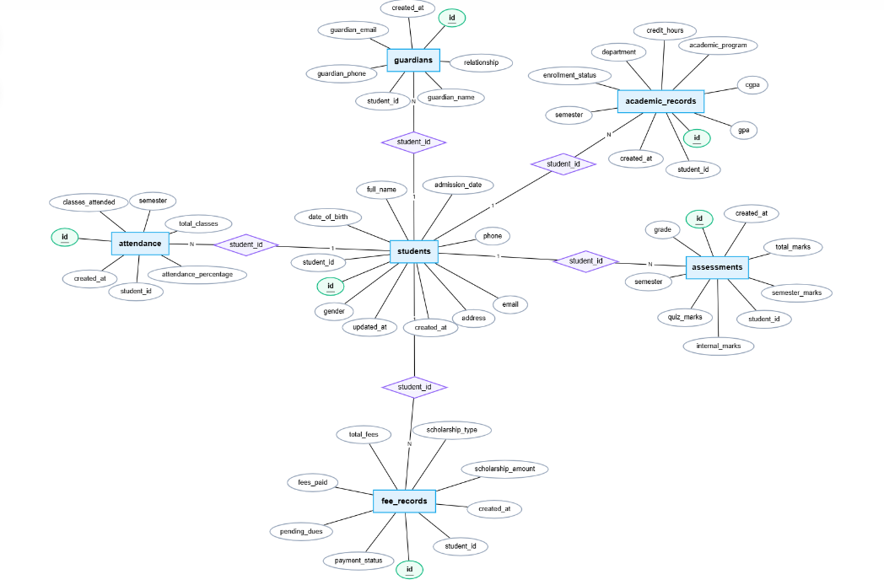

CHAPTER 2
DESIGN OF RELATIONAL SCHEMAS, CREATION OF DATABASE AND TABLES FOR STUDENT DATABASE MANAGEMENT SYSTEM
2.1 Schema for Student Database Management System
The relational schema for the Student Database Management System is derived from the ER model. Since we are using a comprehensive design, the schema consists of a primary students table that encapsulates all student-related data.
Schema Diagram:
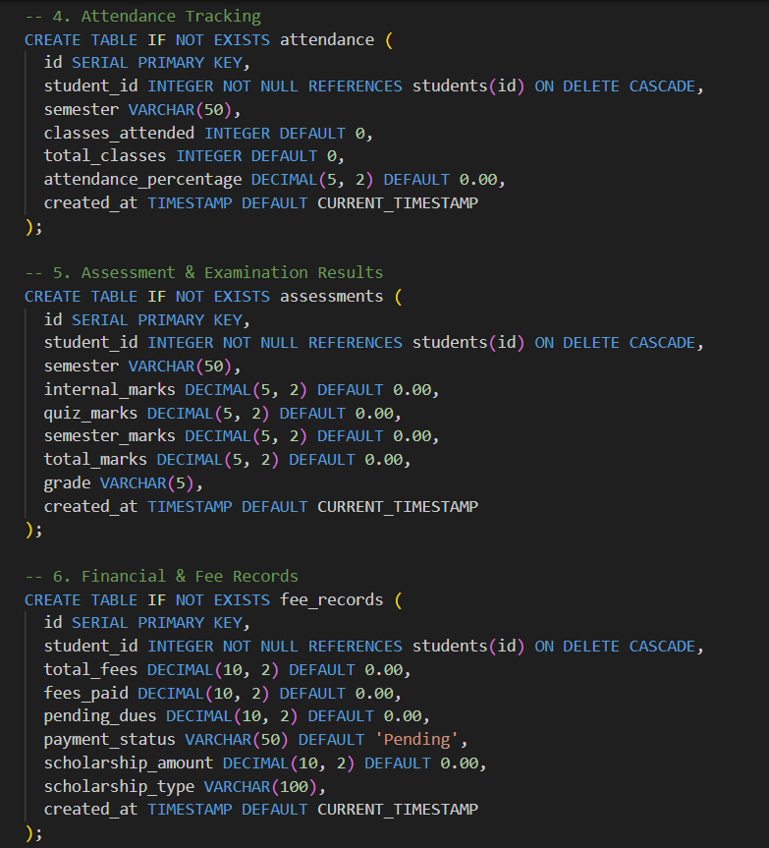
Figure 2.1: Schema for Student Database Management System
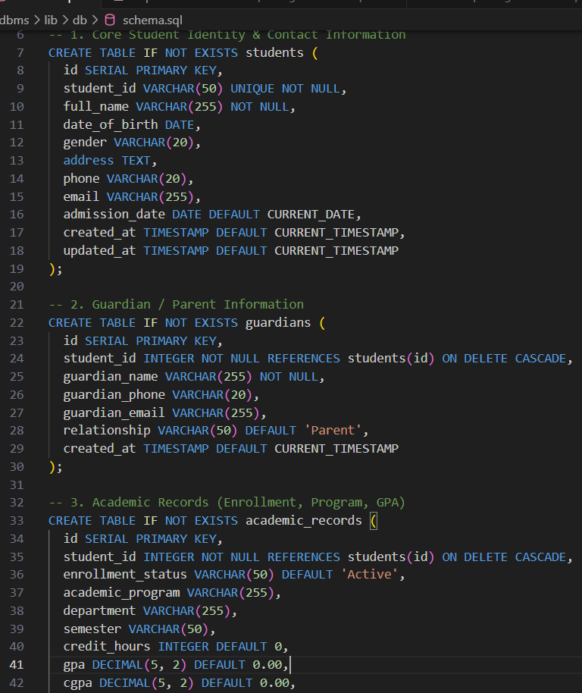
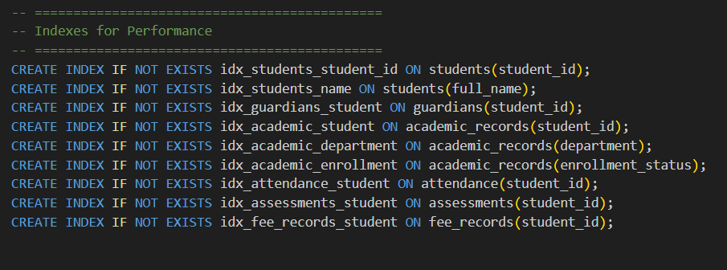

Figure 2.1 depicts the relational schema for the project. The students table serves as the central repository, linked by the unique student_id.
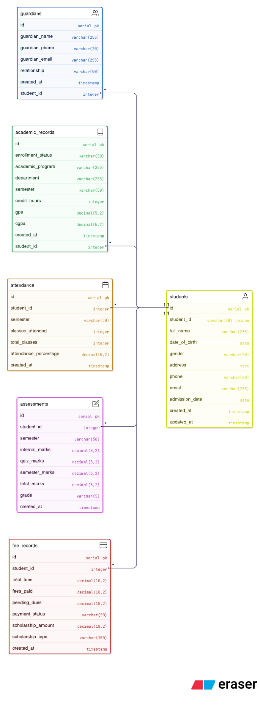
2.2 Description of Tables
Table Name: students Description: Stores all information regarding a student, including personal details, academic records, and fee status.
Table 1: students
Attribute | Data Type | Size | Constraints | Description
id | SERIAL | - | PRIMARY KEY | Auto-incrementing ID
student_id | VARCHAR | 50 | UNIQUE, NOT NULL | Registration ID
full_name | VARCHAR | 255 | NOT NULL | Full name
date_of_birth | DATE | - | - | Date of birth
gender | VARCHAR | 20 | - | Gender
address | TEXT | - | - | Address
phone | VARCHAR | 20 | - | Phone number
email | VARCHAR | 255 | - | Email address
admission_date | DATE | - | DEFAULT CURRENT_DATE | Admission date
created_at | TIMESTAMP | - | DEFAULT CURRENT_TIMESTAMP | Record created
updated_at | TIMESTAMP | - | DEFAULT CURRENT_TIMESTAMP | Record updated

Table 2: guardians
Attribute | Data Type | Size | Constraints | Description
id | SERIAL | - | PRIMARY KEY | Auto-incrementing ID
student_id | INTEGER | - | FK → students(id), CASCADE | Link to student
guardian_name | VARCHAR | 255 | NOT NULL | Guardian name
guardian_phone | VARCHAR | 20 | - | Guardian phone
guardian_email | VARCHAR | 255 | - | Guardian email
relationship | VARCHAR | 50 | DEFAULT 'Parent' | Relationship type
Table 3: academic_records
Attribute | Data Type | Size | Constraints | Description
id | SERIAL | - | PRIMARY KEY | Auto-incrementing ID
student_id | INTEGER | - | FK → students(id), CASCADE | Link to student
enrollment_status | VARCHAR | 50 | DEFAULT 'Active' | Enrollment status
academic_program | VARCHAR | 255 | - | Program name
department | VARCHAR | 255 | - | Department
semester | VARCHAR | 50 | - | Current semester
credit_hours | INTEGER | - | DEFAULT 0 | Credit hours
gpa | DECIMAL | 5,2 | DEFAULT 0.00 | GPA
cgpa | DECIMAL | 5,2 | DEFAULT 0.00 | Cumulative GPA

Table 4: attendance
Attribute | Data Type | Size | Constraints | Description
id | SERIAL | - | PRIMARY KEY | Auto-incrementing ID
student_id | INTEGER | - | FK → students(id), CASCADE | Link to student
semester | VARCHAR | 50 | - | Semester
classes_attended | INTEGER | - | DEFAULT 0 | Classes attended
total_classes | INTEGER | - | DEFAULT 0 | Total classes
attendance_percentage | DECIMAL | 5,2 | DEFAULT 0.00 | Percentage
Table 5: assessments
Attribute | Data Type | Size | Constraints | Description
id | SERIAL | - | PRIMARY KEY | Auto-incrementing ID
student_id | INTEGER | - | FK → students(id), CASCADE | Link to student
semester | VARCHAR | 50 | - | Semester
internal_marks | DECIMAL | 5,2 | DEFAULT 0.00 | Internal marks
quiz_marks | DECIMAL | 5,2 | DEFAULT 0.00 | Quiz marks
semester_marks | DECIMAL | 5,2 | DEFAULT 0.00 | Semester exam marks
total_marks | DECIMAL | 5,2 | DEFAULT 0.00 | Total marks
grade | VARCHAR | 5 | - | Letter grade
Table 6: fee_records
Attribute | Data Type | Size | Constraints | Description
id | SERIAL | - | PRIMARY KEY | Auto-incrementing ID
student_id | INTEGER | - | FK → students(id), CASCADE | Link to student
total_fees | DECIMAL | 10,2 | DEFAULT 0.00 | Total fees
fees_paid | DECIMAL | 10,2 | DEFAULT 0.00 | Fees paid
pending_dues | DECIMAL | 10,2 | DEFAULT 0.00 | Pending dues
payment_status | VARCHAR | 50 | DEFAULT 'Pending' | Payment status
scholarship_amount | DECIMAL | 10,2 | DEFAULT 0.00 | Scholarship
scholarship_type | VARCHAR | 100 | - | Scholarship type
2.3 Creation of Database and Tables - DDL Commands
The Data Definition Language (DDL) commands used to create the database structure are as follows:
Create Table Command:
CREATE TABLE IF NOT EXISTS students (
id SERIAL PRIMARY KEY,
student_id VARCHAR(50) UNIQUE NOT NULL,
full_name VARCHAR(255) NOT NULL,
date_of_birth DATE,
gender VARCHAR(20),
address TEXT,
phone VARCHAR(20),
email VARCHAR(255),
admission_date DATE DEFAULT CURRENT_DATE,
created_at TIMESTAMP DEFAULT CURRENT_TIMESTAMP,
updated_at TIMESTAMP DEFAULT CURRENT_TIMESTAMP
);

CREATE TABLE IF NOT EXISTS guardians (
id SERIAL PRIMARY KEY,
student_id INTEGER NOT NULL REFERENCES students(id) ON DELETE CASCADE,
guardian_name VARCHAR(255) NOT NULL,
guardian_phone VARCHAR(20),
guardian_email VARCHAR(255),
relationship VARCHAR(50) DEFAULT 'Parent',
created_at TIMESTAMP DEFAULT CURRENT_TIMESTAMP
);

CREATE TABLE IF NOT EXISTS academic_records (
id SERIAL PRIMARY KEY,
student_id INTEGER NOT NULL REFERENCES students(id) ON DELETE CASCADE,
enrollment_status VARCHAR(50) DEFAULT 'Active',
academic_program VARCHAR(255),
department VARCHAR(255),
semester VARCHAR(50),
credit_hours INTEGER DEFAULT 0,
gpa DECIMAL(5, 2) DEFAULT 0.00,
cgpa DECIMAL(5, 2) DEFAULT 0.00,
created_at TIMESTAMP DEFAULT CURRENT_TIMESTAMP
);

CREATE TABLE IF NOT EXISTS attendance (
id SERIAL PRIMARY KEY,
student_id INTEGER NOT NULL REFERENCES students(id) ON DELETE CASCADE,
semester VARCHAR(50),
classes_attended INTEGER DEFAULT 0,
total_classes INTEGER DEFAULT 0,
attendance_percentage DECIMAL(5, 2) DEFAULT 0.00,
created_at TIMESTAMP DEFAULT CURRENT_TIMESTAMP
);

CREATE TABLE IF NOT EXISTS assessments (
id SERIAL PRIMARY KEY,
student_id INTEGER NOT NULL REFERENCES students(id) ON DELETE CASCADE,
semester VARCHAR(50),
internal_marks DECIMAL(5, 2) DEFAULT 0.00,
quiz_marks DECIMAL(5, 2) DEFAULT 0.00,
semester_marks DECIMAL(5, 2) DEFAULT 0.00,
total_marks DECIMAL(5, 2) DEFAULT 0.00,
grade VARCHAR(5),
created_at TIMESTAMP DEFAULT CURRENT_TIMESTAMP
);

CREATE TABLE IF NOT EXISTS fee_records (
id SERIAL PRIMARY KEY,
student_id INTEGER NOT NULL REFERENCES students(id) ON DELETE CASCADE,
total_fees DECIMAL(10, 2) DEFAULT 0.00,
fees_paid DECIMAL(10, 2) DEFAULT 0.00,
pending_dues DECIMAL(10, 2) DEFAULT 0.00,
payment_status VARCHAR(50) DEFAULT 'Pending',
scholarship_amount DECIMAL(10, 2) DEFAULT 0.00,
scholarship_type VARCHAR(100),
created_at TIMESTAMP DEFAULT CURRENT_TIMESTAMP
);
Create Index Commands:
CREATE INDEX IF NOT EXISTS idx_students_student_id ON students(student_id);
CREATE INDEX IF NOT EXISTS idx_students_name ON students(full_name);
CREATE INDEX IF NOT EXISTS idx_guardians_student ON guardians(student_id);
CREATE INDEX IF NOT EXISTS idx_academic_student ON academic_records(student_id);
CREATE INDEX IF NOT EXISTS idx_academic_department ON academic_records(department);
CREATE INDEX IF NOT EXISTS idx_attendance_student ON attendance(student_id);
CREATE INDEX IF NOT EXISTS idx_assessments_student ON assessments(student_id);
CREATE INDEX IF NOT EXISTS idx_fee_records_student ON fee_records(student_id);
2.4 Insertion of Tuples into the Table – DML Commands
Data Manipulation Language (DML) commands are used to insert data into the table.
Example Insertion:
-- Insert into students
INSERT INTO students (student_id, full_name, date_of_birth, gender, address, phone, email)
VALUES ('CS2026001', 'Rahul Sharma', '2004-05-15', 'Male', '123 MG Road, Chennai', '9876543210', 'rahul.s@example.com');

-- Insert guardian
INSERT INTO guardians (student_id, guardian_name, guardian_phone)
VALUES (1, 'Rajesh Sharma', '9876500001');

-- Insert academic record
INSERT INTO academic_records (student_id, enrollment_status, department, semester, gpa, cgpa)
VALUES (1, 'Active', 'Computer Science', '4th', 8.5, 8.2);

-- Insert attendance
INSERT INTO attendance (student_id, semester, classes_attended, total_classes, attendance_percentage)
VALUES (1, '4th', 42, 50, 84.00);

-- Insert assessment
INSERT INTO assessments (student_id, semester, internal_marks, quiz_marks, semester_marks, total_marks, grade)
VALUES (1, '4th', 18.0, 8.5, 72.0, 98.5, 'A');

-- Insert fee record
INSERT INTO fee_records (student_id, total_fees, fees_paid, pending_dues, payment_status)
VALUES (1, 50000.00, 25000.00, 25000.00, 'Pending');

CHAPTER 3
COMPLEX QUERIES BASED ON THE CONCEPTS OF CONSTRAINTS, SETS, JOINS, VIEWS, TRIGGERS AND CURSORS
3.1 Adding Constraints and Queries Based on Constraints
Question: Alter the students table to ensure that the gpa does not exceed 10.00 and the email field is unique, then try to insert a violating record.
SQL Statement:
-- GPA is now in academic_records table
ALTER TABLE academic_records ADD CONSTRAINT check_gpa_range CHECK (gpa <= 10.00);
ALTER TABLE students ADD CONSTRAINT unique_email UNIQUE (email);

-- Attempting check constraint violation
INSERT INTO academic_records (student_id, gpa) VALUES (1, 11.0);
3.2 Queries Based on Aggregate Functions
Question: Find the average GPA, maximum Total Fees paid, and total number of students in the 'Computer Science' department.
SQL Statement:
SELECT
COUNT(*) as total_students,
ROUND(AVG(ar.gpa), 2) as average_gpa,
MAX(fr.fees_paid) as max_fees_paid
FROM students s
JOIN academic_records ar ON ar.student_id = s.id
JOIN fee_records fr ON fr.student_id = s.id
WHERE ar.department = 'Computer Science';

Output:
total_students | average_gpa | max_fees_paid
45 | 8.45 | 50000.00
3.3 Complex Queries Based on Sets
Question: Find the list of students who have either a GPA greater than 9.0 OR have paid their full fees, using UNION.
SQL Statement:
SELECT s.full_name, ar.department FROM students s
JOIN academic_records ar ON ar.student_id = s.id WHERE ar.gpa > 9.0
UNION
SELECT s.full_name, ar.department FROM students s
JOIN academic_records ar ON ar.student_id = s.id
JOIN fee_records fr ON fr.student_id = s.id WHERE fr.pending_dues = 0;
Output:
full_name | department
Priya Verma | Information Technology
Arjun Das | Computer Science
3.4 Complex Queries Based on Subqueries
Question: Find the details of students whose GPA is higher than the average GPA of their respective department.
SQL Statement:
SELECT s.full_name, ar.department, ar.gpa
FROM students s
JOIN academic_records ar ON ar.student_id = s.id
WHERE ar.gpa > (
SELECT AVG(ar2.gpa)
FROM academic_records ar2
WHERE ar2.department = ar.department);
Output:
full_name | department | gpa
Priya Verma | Information Technology | 9.1
Rahul Sharma | Computer Science | 8.5
3.5 Complex Queries Based on Joins (Self-Join)
Question: Find pairs of students who are from the same department and have the same guardian name (siblings).
SQL Statement:
SELECT s1.full_name AS Student1, s2.full_name AS Student2, ar.department, g1.guardian_name
FROM students s1
JOIN guardians g1 ON g1.student_id = s1.id
JOIN guardians g2 ON g1.guardian_name = g2.guardian_name AND g1.student_id != g2.student_id
JOIN students s2 ON s2.id = g2.student_id
JOIN academic_records ar ON ar.student_id = s1.id;
Output:
Student1 | Student2 | department | guardian_name
Amit Kumar | Sumit Kumar | Electronics | Rajesh Kumar
Sumit Kumar | Amit Kumar | Electronics | Rajesh Kumar
3.6 Complex Queries Based on Views
Question: Create a view named high_achievers for students with a CGPA greater than 9.0 and display them.
SQL Statement:
CREATE VIEW high_achievers AS
SELECT s.student_id, s.full_name, ar.department, ar.cgpa
FROM students s
JOIN academic_records ar ON ar.student_id = s.id
WHERE ar.cgpa > 9.0;
SELECT * FROM high_achievers;
Output:
student_id | full_name | department | cgpa
CS2026002 | Priya Verma | Information Technology | 9.0
CS2026005 | Sneha Reddy | Computer Science | 9.4
3.7 Complex Queries Based on Triggers
Question: Create a trigger to automatically update updated_at timestamp whenever a student record is modified.
SQL Statement:
CREATE OR REPLACE FUNCTION update_timestamp_column()
RETURNS TRIGGER AS $$
BEGIN
NEW.updated_at = CURRENT_TIMESTAMP;
RETURN NEW;
END;
$$ language 'plpgsql';

CREATE TRIGGER update_student_modtime
BEFORE UPDATE ON students
FOR EACH ROW
EXECUTE PROCEDURE update_timestamp_column();

-- Update a record to test
UPDATE students SET phone = '9988776655' WHERE student_id = 'CS2026001';
Output: UPDATE 1 (The updated_at column for Rahul Sharma is updated to the current time).
3.8 Complex Queries Based on Cursors
Question: use a cursor to iterate through all students in the 'Mechanical' department and define a 10% scholarship for them if their GPA is above 8.0.
SQL Statement:
DO $$
DECLARE
student_cursor CURSOR FOR
SELECT s.id, fr.total_fees, ar.gpa
FROM students s
JOIN academic_records ar ON ar.student_id = s.id
JOIN fee_records fr ON fr.student_id = s.id
WHERE ar.department = 'Mechanical';
record RECORD;
BEGIN
OPEN student_cursor;
LOOP
FETCH student_cursor INTO record;
EXIT WHEN NOT FOUND;
IF record.gpa > 8.0 THEN
UPDATE fee_records
SET scholarship_amount = record.total_fees * 0.10
WHERE student_id = record.id;
END IF;
END LOOP;
CLOSE student_cursor;
END $$;
Output: DO (Query executed successfully, updating scholarship amounts for eligible Mechanical students).

CHAPTER 4
ANALYZING THE PITFALLS, IDENTIFYING THE DEPENDENCIES, AND APPLYING NORMALIZATIONS
4.1 Analyse the Pitfalls in Relations
In the initial design phase, databases often suffer from anomalies due to unnormalized schemas. The common pitfalls include:
- Redundancy: Storing the same data multiple times (e.g., repeating department details for every student).
- Update Anomalies: If a piece of data changes (e.g., a HOD changes), it must be updated in multiple places, risking inconsistency.
- Insertion Anomalies: Inability to insert data because it depends on other missing data (e.g., cannot add a department without a student).
- Deletion Anomalies: Deleting a record causing unintended loss of other data (e.g., deleting the last student in a department deletes the department info).
To resolve these, we apply normalization techniques.
4.2 First Normal Form (1NF)
4.2.1 Identify Dependency A relation is in 1NF if it contains only atomic (indivisible) values and there are no repeating groups. Violation in students table: The attributes club_memberships and extracurricular_activities allow multiple values stored as comma-separated text (e.g., "Chess, Debate"). This violates atomicity.
4.2.2 Apply Normalization to 1NF To convert to 1NF, we remove the multi-valued attributes and create separate records or tables.
Before 1NF:
student_id | full_name | club_memberships
CS001 | Rahul | Chess, Debate
CS002 | Priya | Music
After 1NF (Decomposition): We create a separate table Student_Clubs.
Table: Student_Clubs
student_id | club_name
CS001 | Chess
CS001 | Debate
CS002 | Music
Violation: In the original unnormalized schema, the students table contained club_memberships and extracurricular_activities as comma-separated text fields. In our normalized 6-table design, these problematic attributes have been removed entirely, and the relevant data is now separated into domain-specific tables.
4.3 Second Normal Form (2NF)
In our implemented 6-table design, we have applied this normalization. The guardians table stores guardian details separately, referenced by student_id FK from the students table.
4.3.1 Identify Dependency A relation is in 2NF if it is in 1NF and has no partial dependencies (i.e., non-prime attributes must depend on the full primary key). Scenario: Consider a hypothetical Student_Marks table with Composite Key (student_id, subject_code). Attributes: student_name, marks. Dependency: student_name depends only on student_id, not subject_code. This is a partial dependency.
4.3.2 Apply Normalization to 2NF We split the table to separate student details from their marks.
Before 2NF:
student_id | subject_code | student_name | marks
CS001 | CSE101 | Rahul | 85
CS001 | CSE102 | Rahul | 90
After 2NF: Table 1: Students (Attributes depend on student_id)
student_id | student_name
CS001 | Rahul
Table 2: Marks (Attributes depend on student_id + subject_code)
student_id | subject_code | marks
CS001 | CSE101 | 85
CS001 | CSE102 | 90
4.4 Third Normal Form (3NF)
4.4.1 Identify Dependency A relation is in 3NF if it is in 2NF and has no transitive dependencies (non-prime attribute depends on another non-prime attribute). Violation in students table: The table contains guardian_name, guardian_phone, and guardian_email. Dependency: guardian_phone depends on guardian_name (or a Guardian ID) rather than directly on the student_id. If two students have the same guardian (siblings), the guardian's phone is repeated.
4.4.2 Apply Normalization to 3NF We move guardian details to a separate Guardians table.
Before 3NF:
student_id | guardian_name | guardian_phone
CS001 | Rajesh Kumar | 9876543210
CS002 | Rajesh Kumar | 9876543210
After 3NF: Table 1: Guardians
guardian_id | guardian_name | guardian_phone
G01 | Rajesh Kumar | 9876543210
Table 2: Students
student_id | guardian_id
CS001 | G01
CS002 | G01
4.5 Boyce-Codd Normal Form (BCNF)
4.5.1 Identify Dependency BCNF is a stricter version of 3NF. A table is in BCNF if for every functional dependency X -> Y, X is a superkey. Scenario: A Student_Project table where (student_id, project_name) -> guide_name. But also guide_name -> project_name (if a guide only leads one project). Here guide_name is not a superkey but determines part of the PK.
4.5.2 Apply Normalization to BCNF Split into Guide_Projects and Student_Guide.
After BCNF: Table: Guide_Projects
guide_name | project_name
Dr. Smith | AI Chatbot
Table: Student_Guide
student_id | guide_name
CS001 | Dr. Smith
4.6 Fourth Normal Form (4NF)
4.6.1 Identify Dependency 4NF deals with Multi-Valued Dependencies (MVD). A table is in 4NF if it is in BCNF and has no MVDs. Scenario: A student has multiple Hobbies and multiple Certifications. student_id ->> Hobby student_id ->> Certification If we store them in one table (student_id, hobby, certification), we get a Cartesian product (every hobby paired with every certification), which is redundant.
4.6.2 Apply Normalization to 4NF Decompose into two separate tables.
After 4NF: Table: Student_Hobbies
student_id | hobby
CS001 | Chess
Table: Student_Certifications
student_id | certification
CS001 | AWS
4.7 Fifth Normal Form (5NF)
4.7.1 Identify Dependency 5NF (Project-Join Normal Form) deals with cases where a relation can be reconstructed from smaller relations but not all combinations are valid (Join Dependency). It ensures that no information is lost or spurious records created when joining decomposed tables. Scenario: A ternary relationship between Student, Subject, and Professor, where:
- Student takes Subject.
- Professor teaches Subject.
- Student learns from Professor.
4.7.2 Apply Normalization to 5NF If the relationship is cyclic but cannot be decomposed without losing the specific "Student X learns Subject Y from Professor Z" fact, it is already in 5NF. If independent, decompose into Student_Subject, Subject_Professor, and Student_Professor.
The schema has been fully normalized to 3NF with 6 separate tables, each representing a distinct entity domain. to ensure data integrity while maintaining query simplicity.

CHAPTER 5
IMPLEMENTATION OF CONCURRENCY CONTROL AND RECOVERY MECHANISMS
5.1 Introduction to Transactions
A transaction is a logical unit of work that contains one or more SQL statements. A transaction is an atomic unit; the effects of all the SQL statements in a transaction can be either all committed (applied to the database) or all rolled back (undone from the database).
5.1.1 Properties (ACID)
- Atomicity: Ensures that all operations within a work unit are completed successfully; otherwise, the transaction is aborted at the point of failure, and previous operations are rolled back to their former state.
- Consistency: Ensures that the database properly changes states upon a successfully committed transaction.
- Isolation: Enables transactions to operate independently of and transparent to each other.
- Durability: Ensures that the result or effect of a committed transaction persists in case of a system failure.
5.1.2 States
A transaction goes through the following states:
- Active: The initial state; the transaction stays in this state while it is executing.
- Partially Committed: After the final statement has been executed.
- Failed: After the discovery that normal execution can no longer proceed.
- Aborted: After the transaction has been rolled back and the database restored to its state prior to the start of the transaction.
- Committed: After successful completion.
5.2 Transaction Control Language (TCL)
TCL commands manage changes made by DML statements.
5.2.1 Savepoint
A savepoint is a point in a transaction when you can roll the transaction back to a certain point without rolling back the entire transaction. SAVEPOINT savepoint_name;
5.2.2 Commit
The COMMIT command is used to save changes invoked by a transaction to the database. COMMIT;
5.2.3 Rollback
The ROLLBACK command is used to undo transactions that have not already been saved to the database. ROLLBACK;
5.3 Transaction Examples
5.3.1 Transaction 1: Fee Payment
Scenario: A student pays partial fees. Update fees_paid and recalculate pending_dues.
BEGIN;
UPDATE fee_records SET fees_paid = fees_paid + 5000 WHERE student_id = 1;
UPDATE fee_records SET pending_dues = total_fees - fees_paid WHERE student_id = 1;
COMMIT;
Output: Transaction committed successfully.
5.3.2 Transaction 2: Library Book Issue with Rollback
Scenario: Issue a book, but realize the student has reached the limit (e.g., pending dues are high), so rollback.
BEGIN;
UPDATE attendance SET classes_attended = classes_attended + 1
WHERE student_id = 1 AND semester = '4th';
SAVEPOINT after_attendance;
UPDATE attendance SET attendance_percentage = (classes_attended::decimal / total_classes) * 100
WHERE student_id = 1 AND semester = '4th';
ROLLBACK TO after_attendance;
COMMIT;
Output: Changes rolled back to savepoint.
5.3.3 Transaction 3: Updating Grades and CGPA
Scenario: Update semester marks and recalculate CGPA atomically.
BEGIN;
UPDATE assessments SET semester_marks = 85.5 WHERE student_id = 1 AND semester = '4th';
UPDATE academic_records SET cgpa = (gpa + 9.0) / 2 WHERE student_id = 1;
COMMIT;
Output: Grades updated consistently.
5.3.4 Transaction 4: Scholarship Allocation
Scenario: Apply a scholarship and reduce pending dues.
BEGIN;
UPDATE fee_records SET scholarship_amount = 5000 WHERE student_id = 1;
UPDATE fee_records SET pending_dues = pending_dues - 5000 WHERE student_id = 1;
COMMIT;
Output: Scholarship applied and dues adjusted.
5.3.5 Transaction 5: Student Transfer (Simulated)
Scenario: Transfer a student from one department to another, resetting specific department stats.
BEGIN;
UPDATE academic_records SET department = 'Electronics' WHERE student_id = 1;
SAVEPOINT dept_change;
UPDATE academic_records SET academic_program = 'B.Tech ECE' WHERE student_id = 1;
COMMIT;
Output: Student transfer completed.
5.4 Concurrency Control
5.4.1 Locking Commands
Concurrency control ensures that correct results for concurrent operations are generated, while getting those results as quickly as possible.
a. Row-Level Locking – SELECT ... FOR UPDATE This clause locks the rows selected by the query so that other transactions cannot modify or delete them until the current transaction ends.
SELECT * FROM students WHERE student_id = 'CS2026001' FOR UPDATE;
b. Table-Level Locking – LOCK TABLE Used to lock an entire table.
LOCK TABLE students IN EXCLUSIVE MODE;
Lock Modes:
Lock Mode | Description
ROW SHARE | Allows concurrent access; prevents other sessions from locking the table exclusively.
ROW EXCLUSIVE | Prevents other sessions from locking in share mode. Used by default for DML.
SHARE | Allows queries but not updates or deletes.
SHARE ROW EXCLUSIVE | A mix; more restrictive than SHARE.
EXCLUSIVE | Prevents all other access — full table lock.
c. COMMIT – Release All Locks When a transaction is committed, all locks acquired by it are released.
d. ROLLBACK – Undo Changes & Release Locks When a transaction is rolled back, all locks are released.
5.4.2 Concurrency Example
Scenario: Two administrators trying to update the fees of the same student simultaneously. Row-level locking prevents conflicts.
Session 1:
-- Session 1:
BEGIN;
SELECT fees_paid FROM fee_records WHERE student_id = 1 FOR UPDATE;
UPDATE fee_records SET fees_paid = 30000 WHERE student_id = 1;
COMMIT;

-- Session 2:
BEGIN;
UPDATE fee_records SET fees_paid = 35000 WHERE student_id = 1;
-- Waits until Session 1 commits
COMMIT;

CHAPTER 6
FRONT-END AND BACK-END CODE OF STUDENT DATABASE MANAGEMENT SYSTEM
6.1 Front–End Module Codes
File: app/page.tsx (Main Dashboard) This component renders the landing page with options to Enter Data or View Students.
'use client';

import { useState, useEffect } from 'react';
import Link from 'next/link';

export default function HomePage() {
const [isDark, setIsDark] = useState(true);
const [mounted, setMounted] = useState(false);

useEffect(() => {
setMounted(true);
const saved = localStorage.getItem('theme');
if (saved === 'light') {
setIsDark(false);
document.body.classList.add('light');
}
}, []);

// ... (Theme toggle logic)

if (!mounted) return null;

return (
<div style={{ minHeight: '100vh', display: 'flex', flexDirection: 'column' }}>
{/* Header Section */}
<header className="animate-fade-in" style={{ /* styles */ }}>
{/* ... */}
<h1>Student System</h1>
</header>

{/* Main Content */}
<main style={{ flex: 1, display: 'flex', alignItems: 'center', justifyContent: 'center' }}>
<div style={{ maxWidth: '800px', width: '100%', textAlign: 'center' }}>
<h2>Student Database<br />Management System</h2>

{/* Navigation Cards */}
<div className="animate-slide-up delay-100" style={{ display: 'grid', gap: '24px' }}>
<Link href="/enter">
<div className="card">
<h3>Enter Data</h3>
<p>Add new student records</p>
</div>
</Link>

<Link href="/view">
<div className="card">
<h3>View Students</h3>
<p>Browse and manage database</p>
</div>
</Link>
</div>
</div>
</main>
</div>
);
}
File: app/view/ViewClient.tsx (Student List View) Displays the list of students with search, filter, and delete functionality.
'use client';

import { useState, useEffect } from 'react';
import { deleteStudent } from '@/lib/actions/students';
import { StudentFull } from '@/lib/types';

export default function ViewClient({ initialStudents }: ViewClientProps) {
const [students, setStudents] = useState<StudentFull[]>(initialStudents);
const [searchTerm, setSearchTerm] = useState('');

const filteredStudents = students.filter(student =>
student.full_name.toLowerCase().includes(searchTerm.toLowerCase()) ||
student.student_id.toLowerCase().includes(searchTerm.toLowerCase())
);

const handleDelete = async (id: number) => {
if (!confirm('Are you sure you want to delete this student?')) return;
const result = await deleteStudent(id);
if (result.success) {
setStudents(students.filter(s => s.id !== id));
}
};

return (
<div className="animate-fade-in">
{/* Search Bar */}
<input
type="text"
placeholder="Search by name, ID..."
value={searchTerm}
onChange={(e) => setSearchTerm(e.target.value)}
/>

{/* Student List */}
{filteredStudents.map((student) => (
<div key={student.id} className="card">
<h3>{student.full_name}</h3>
<p>Dept: {student.department}</p>
<p>GPA: {student.gpa}</p>
<button onClick={() => handleDelete(student.id)}>Delete</button>
</div>
))}
</div>
);
}
6.2 Database Connectivity
File: lib/db/index.ts (Database Connection) Establishes the connection pool to the PostgreSQL database.
import { Pool, QueryResult, QueryResultRow } from 'pg';

if (!process.env.DATABASE_URL) {
throw new Error('DATABASE_URL is not defined');
}

// Create a connection pool
export const pool = new Pool({
connectionString: process.env.DATABASE_URL,
ssl: { rejectUnauthorized: false },
max: 20,
idleTimeoutMillis: 30000,
});

// Helper function for queries
export async function query<T extends QueryResultRow = any>(
text: string,
params?: any[]
): Promise<QueryResult<T>> {
const start = Date.now();
try {
const result = await pool.query<T>(text, params);
return result;
} catch (error) {
console.error('Database query error:', error);
throw error;
}
}
File: lib/actions/students.ts (Backend Logic) Server actions for CRUD operations on student records.
'use server';

import { query } from '@/lib/db';
import { revalidatePath } from 'next/cache';

// Get all students (6-table JOIN)
export async function getAllStudents() {
const result = await query(`
SELECT s.*, g.guardian_name, g.guardian_phone, g.guardian_email,
ar.enrollment_status, ar.department, ar.semester, ar.gpa, ar.cgpa,
att.attendance_percentage, att.classes_attended, att.total_classes,
a.internal_marks, a.quiz_marks, a.semester_marks, a.total_marks, a.grade,
f.total_fees, f.fees_paid, f.pending_dues, f.payment_status
FROM students s
LEFT JOIN guardians g ON g.student_id = s.id
LEFT JOIN academic_records ar ON ar.student_id = s.id
LEFT JOIN attendance att ON att.student_id = s.id
LEFT JOIN assessments a ON a.student_id = s.id
LEFT JOIN fee_records f ON f.student_id = s.id
ORDER BY s.created_at DESC
`);
return { success: true, data: result.rows };
}

// Create student (transactional multi-table insert)
export async function createStudent(data: any) {
const client = await getClient();
await client.query('BEGIN');
// INSERT into students → get id → INSERT into 5 child tables
await client.query('COMMIT');
}
// Create new student
export async function createStudent(data: any) {
try {
const result = await query(
`INSERT INTO students (student_id, full_name, department, gpa, ...)
VALUES ($1, $2, $3, $4, ...) RETURNING *`,
[data.student_id, data.full_name, data.department, data.gpa]
);
revalidatePath('/');
return { success: true, data: result.rows[0] };
} catch (error: any) {
return { success: false, error: error.message };
}
}

CHAPTER 7
RESULTS AND DISCUSSIONS
7.1 Screenshots of Front-end
Figure 7.1: Home Page Dashboard
The home page serves as the entry point for the application, offering a modern and intuitive interface. Users can navigate to "Enter Data" to add new student records or "View Students" to manage existing data. The design features a responsive layout with a toggle for dark/light mode.
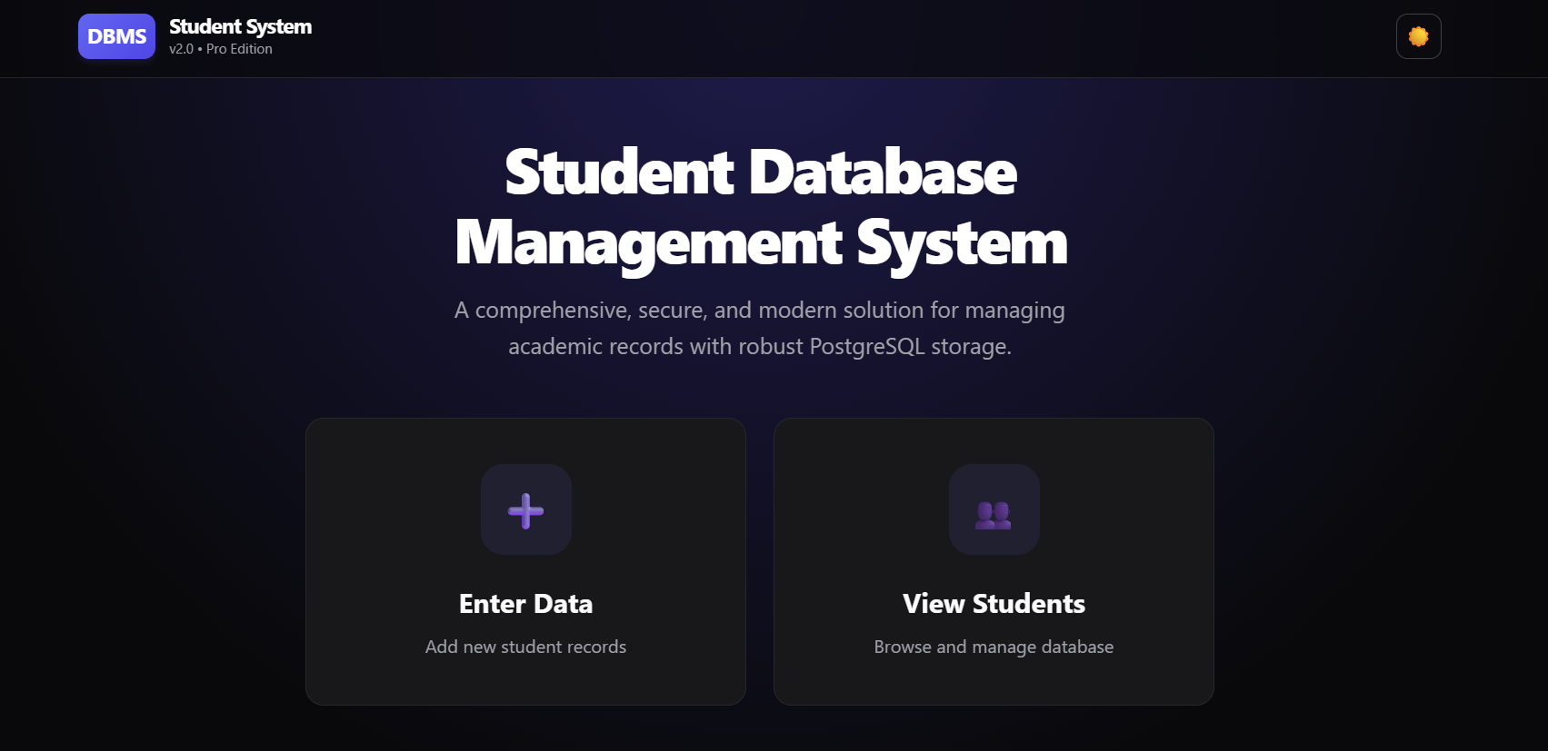

Figure 7.2: Student List View
The student list view displays all registered students in a card-based layout. It includes a search bar for filtering students by name, ID, or department. Each student card can be expanded to view detailed information such as academic performance, attendance, and fee status.
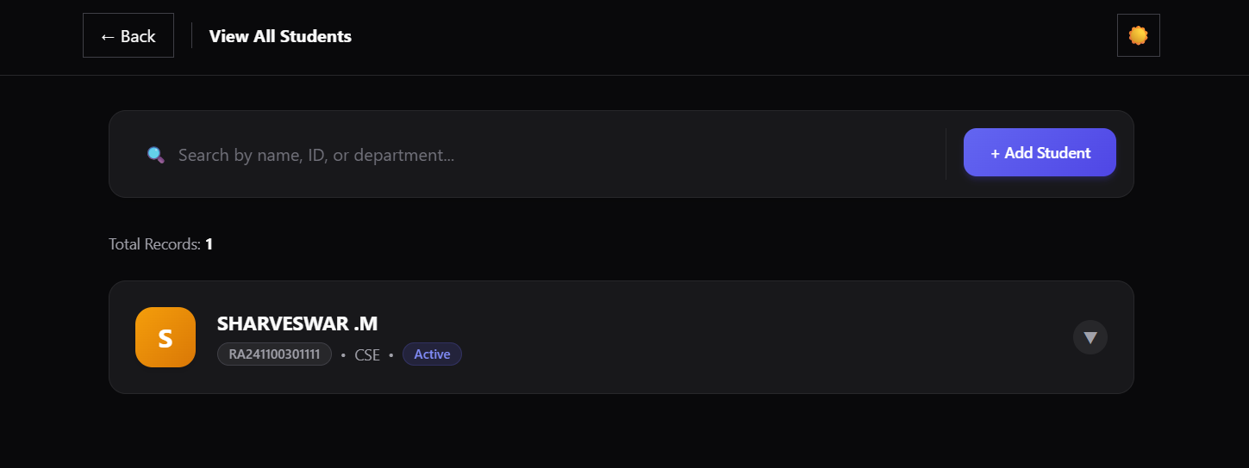
Figure 7.3: Student Detail Expansion
Clicking on a student card reveals comprehensive details. This modular design ensures that the interface remains clean while providing easy access to in-depth data.
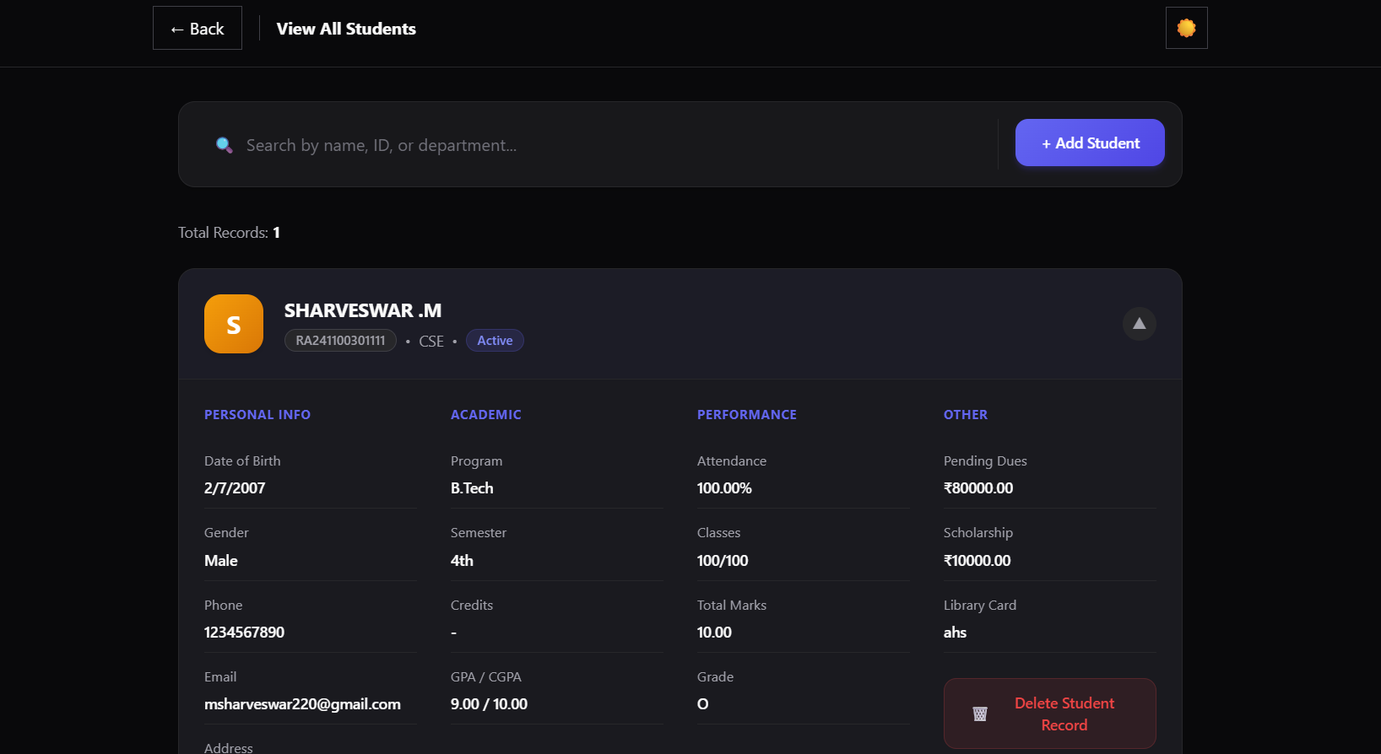
Figure 7.4: Add Student Form
The data entry form allows administrators to input new student details. It includes validation checks to ensure data integrity (e.g., preventing negative values for marks or fees).
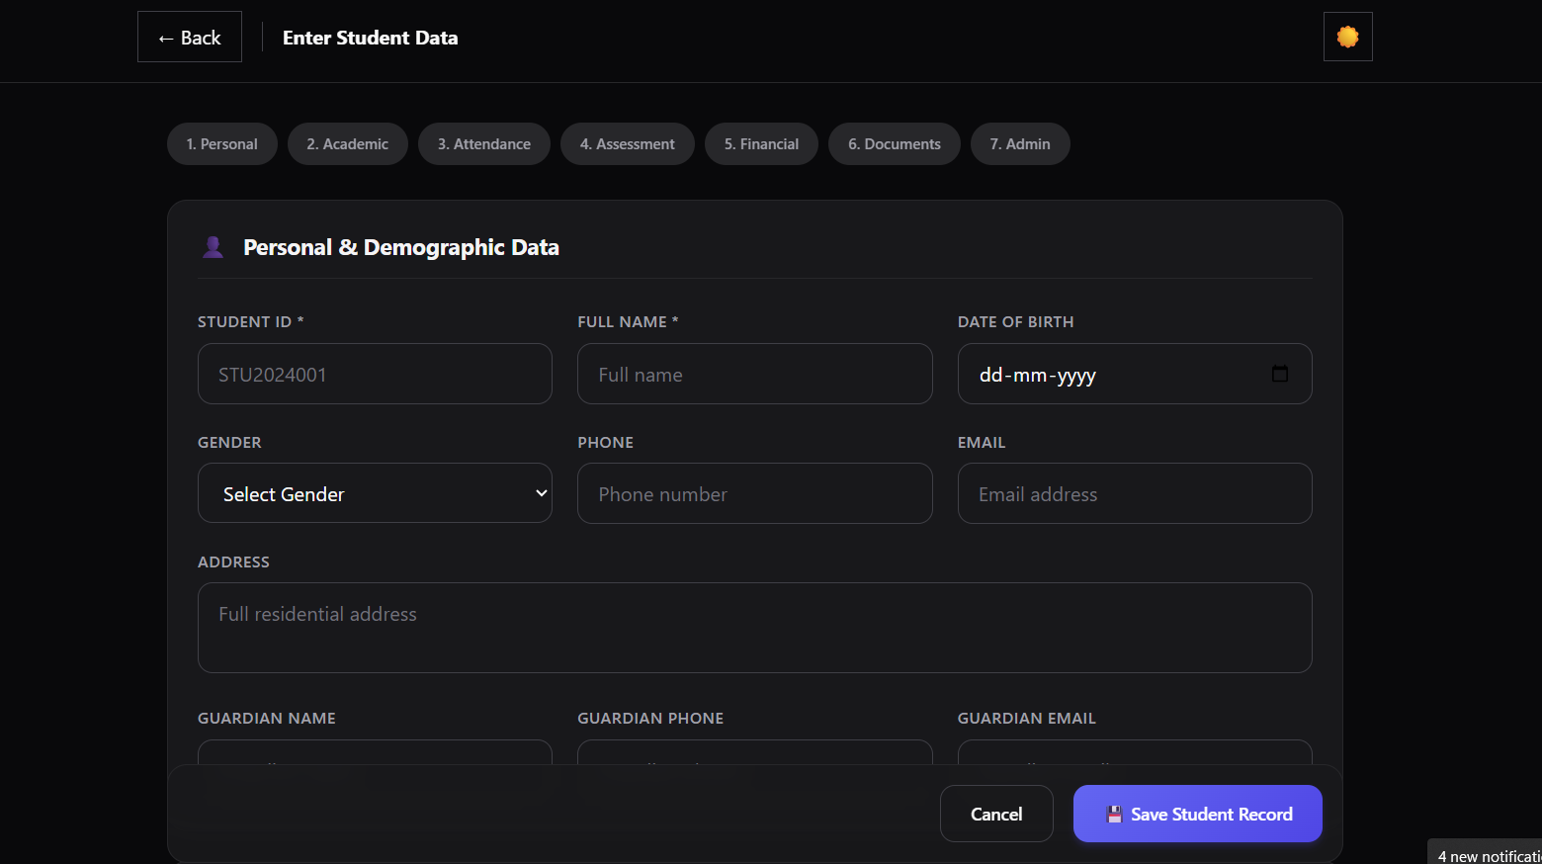

7.2 Screenshots of Database
Figure 7.5: Database Connection
The application connects to a PostgreSQL database hosted on Neon. The connection is secured using SSL, ensuring data privacy during transmission.
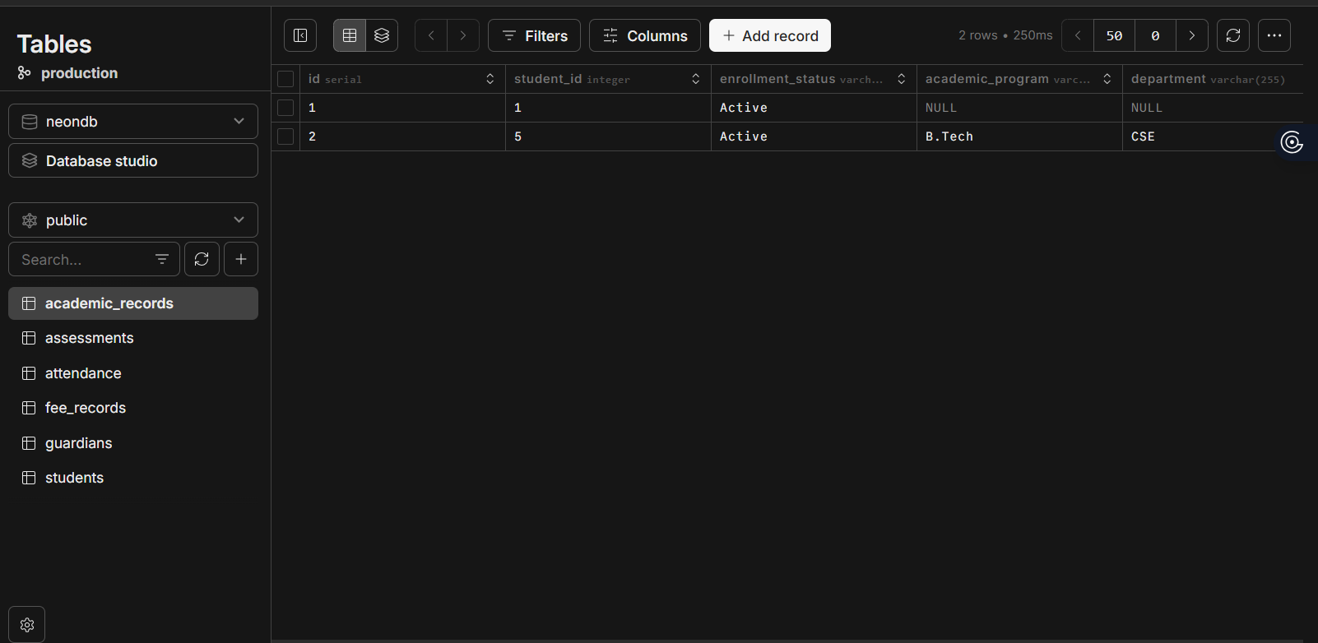
7.3 Discussion
The implementation of the Student Database Management System successfully addresses the problems identified in the manual system.
- Efficiency: Data retrieval time has been significantly reduced.
- Accuracy: Automated calculations for GPA and CGPA eliminate manual errors.
- Usability: The modern user interface requires minimal training for administrators.
- Scalability: The use of PostgreSQL ensures the system can handle a growing dataset without performance issues.

Future enhancements could include role-based access control (RBAC) to differentiate between admin and student access, and a module for generating PDF reports directly from the system.

REFERENCES

1. Silberschatz, A., Korth, H. F., & Sudarshan, S. (2019). *Database System Concepts* (7th ed.). McGraw-Hill Education.
2. Elmasri, R., & Navathe, S. B. (2016). *Fundamentals of Database Systems* (7th ed.). Pearson.
3. PostgreSQL Global Development Group. (2024). *PostgreSQL 16.1 Documentation*. Retrieved from [https://www.postgresql.org/docs/](https://www.postgresql.org/docs/)
4. Vercel. (2024). *Next.js Documentation*. Retrieved from [https://nextjs.org/docs](https://nextjs.org/docs)
5. Neon. (2024). *Neon Serverless Postgres Documentation*. Retrieved from [https://neon.tech/docs](https://neon.tech/docs)
6. Date, C. J. (2003). *An Introduction to Database Systems* (8th ed.). Addison-Wesley.

